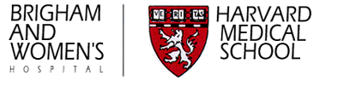

Division of Rheumatology, Immunobiology & Inflammation
Hale Building for Transformative Medicine
60 Fenwood Road
Boston, MA 02115

Research Associate – Bacteriology and Biochemistry
Brigham and Women’s Hospital
Spring or Summer 2021

The Moody laboratory at Brigham and Women’s Hospital seeks a Research Assistant with interest in biochemistry, molecular biology, or cell biology. Successful applicants will join a collaborative, discovery-focused team, where they will work in a modern, well-equipped scientific laboratory towards discovery of new molecules in Mycobacterium tuberculosis and other bacteria. The research assistant will receive training in biochemistry, mass spectrometry, and bioinformatics to support career development.

We are seeking highly motivated applicants with a Bachelor’s Degree or Master’s Degree granted prior to the start date in spring or summer of 2021. Experience with biochemistry, molecular biology or genomics is preferred, but all applicants with documented laboratory experience will be considered.

Please contact Jacob Mayfield, PhD, at jamayfield@bwh.harvard.edu for more information and to apply. Applications should include a brief statement of interest, current CV and list of references. Read more about the Moody lab and this NIH-funded Tuberculosis Research Unit at: https://projects.iq.harvard.edu/tbru/people/d-branch-moody

